

Assignment 1

Kaustubh Jagtap – A0168820B



National University of singapore

**ER DIAGRAM**

A close up of a map

Description generated with high confidence

**RELATIONS**

TWEETSTREAM (tweetstreamID, date_time)

USER (userID, username, fullName, numFriends, numFollowers, profileDesc, profileURL, imageURL,  
 numTweets)

TWEET (tweetID, content, creationDatetime, creationTimezone, postingDatetime, postingTimezone,  
 country, longitude, latitude, sentiment, **tweetStreamID**, **userID**)

MENTION (**userID**, **tweetID**)

REPOST (**tweetID**, **userID**, retweetDatetime)

CAMPUSTAG (**tweetID**, category)

URL (**tweetID**, link, type)

HASHTAG (**tweetID**, tag)

**BOLD – Foreign Key**

Underline – Primary Key

**DATA TYPES**

|  |  |  |  |
| --- | --- | --- | --- |
| **Relation** | **Attribute** | **Comment** | **Data Type** |
| TWEETSTREAM | tweetstreamID | Primary | BIGINT |
| date_time |  | DATETIME |
| TWEET | tweetID | Primary | BIGINT |
| content |  | TEXT |
| creationDatetime |  | DATETIME |
| creationTimezone |  | TINYINT |
| postingDatetime |  | DATETIME |
| postingTimezone |  | TINYINT |
| country |  | VARCHAR (74) |
| longitude |  | DECIMAL (9,6) |
| latitude |  | DECIMAL (9,6) |
| sentiment |  | TINYINT |
| tweetStreamID | Foreign | BIGINT |
| userID | Foreign | BIGINT |
| USER | userID | Primary | BIGINT |
| username |  | VARCHAR (50) |
| fullName |  | VARCHAR (100) |
| profileURL |  | VARCHAR (100) |
| profileDesc |  | TEXT |
| numFollowers |  | INT |
| numFriends |  | INT |
| imageURL |  | VARCHAR (100) |
| numTweets |  | INT |
| MENTION | userID | Primary, Foreign | BIGINT |
| tweetID | Primary, Foreign | BIGINT |
| REPOST | tweetID | Primary, Foreign | BIGINT |
| userID | Primary, Foreign | BIGINT |
| retweetDateTime |  | DATETIME |
| CAMPUSTAG | tweetID | Primary, Foreign | BIGINT |
| category | Primary | CHAR (15) |
| URL | tweetID | Primary, Foreign | BIGINT |
| link | Primary | VARCHAR (100) |
| type |  | TINYINT |
| HASHTAG | tweetID | Primary, Foreign | BIGINT |
| tag | Primary | VARCHAR (50) |

**Assumptions and Clarifications**

* TWEET.country will be stored as VARCHAR (74) since the longest country name is 74 characters.
* TWEET.content of the tweet has to be stored as TEXT since it can go up to 280 characters.
* URL.type is for now just 0 and 1, to signify whether it is external or twitter media. This leaves space to introduce a higher level of classification (say within external), and this can be done by using more integers to signify the types.
* Another table to store followers and friends between users could have been created, but I decided against this since this would make the database unnecessarily large and clunky. (Imagine having to store 500 followers for every person within Singapore, we would have to store the entire user profile of everyone in that network, even globally, and this would have a chain effect). For our purpose of sentiment analysis, simply knowing the number of friends and followers is enough to get a gauge of the person’s influence.
* A separate table has to be created for REPOST because we need a way for the original tweet to be referenced. Also, no additional content or data is created for a retweet, other than the date and time of the new tweet.

**SQL CODE**

A picture containing fence

Description generated with high confidence

**Tables in Database**

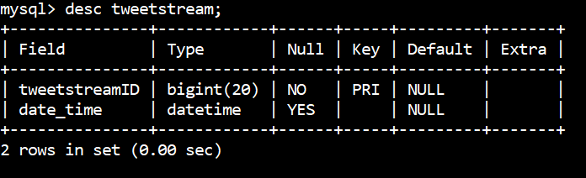

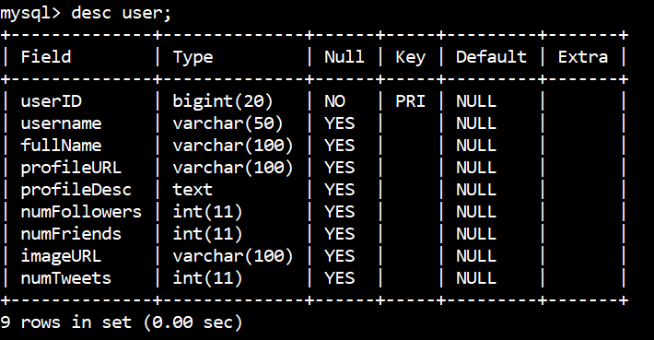

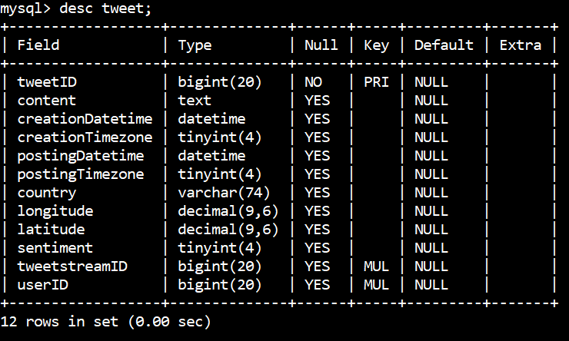

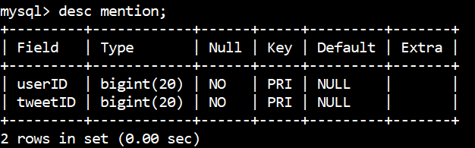

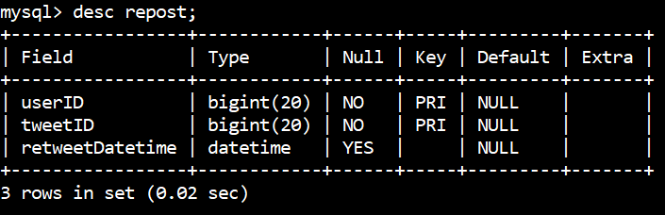

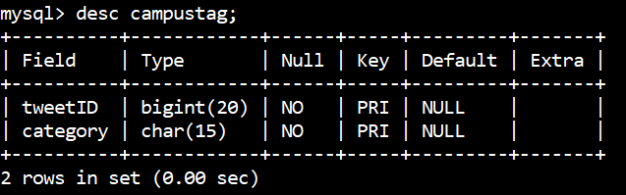

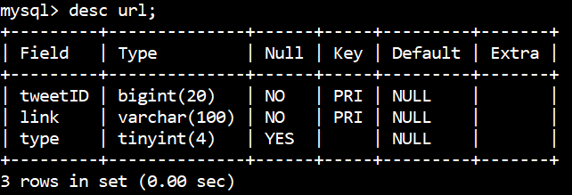

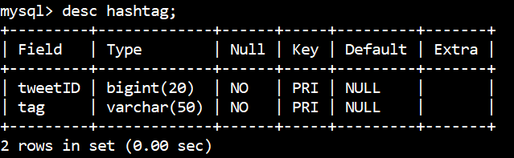

**QUERIES**

1. For every country available in our data, how many tweets originated from there?

SELECT country, count(*) as numTweets

FROM tweet GROUP BY country;

1. What are the 10 most common user hashtags used in our collected tweets?

SELECT tag, count(*) as numTags

FROM hashtag GROUP BY tag

ORDER BY numTags

DESC LIMIT 10;

1. Who is the most influential twitter user in our stream? **(Use number of followers as proxy for influence)**

SELECT * FROM user

WHERE numFollowers =

(SELECT MAX(numFollowers) FROM user);

1. How many tweets are there for each sentiment?

SELECT sentiment, count(*) AS numTweets  
FROM tweet GROUP BY sentiment;

1. (i) Which faculty has the most tweets with a positive sentiment?

SELECT category AS campus, count(*) AS numTweets  
FROM campustag INNER JOIN tweet  
ON tweet.tweetID = campustag.tweetID  
WHERE sentimentID = 1

GROUP BY campus

ORDER BY numTweets  
DESC LIMIT 1;

(ii) Which faculty has the least tweets with a positive sentiment?

SELECT category AS campus, count(*) AS numTweets  
FROM campustag INNER JOIN tweet  
ON tweet.tweetID = campustag.tweetID  
WHERE sentimentID = 1

GROUP BY campus

ORDER BY numTweets  
ASC LIMIT 1;

(iii) Which faculty has the most tweets with a negative sentiment? – **extension of question**

SELECT category AS campus, count(*) AS numTweets  
FROM campustag INNER JOIN tweet  
ON tweet.tweetID = campustag.tweetID  
WHERE sentimentID = -1

GROUP BY campus

ORDER BY numTweets  
DESC LIMIT 1;

1. (i) What were the most common open-day related hashtags (other than #NUSOpenDay18)?

CREATE TABLE temp AS

(SELECT tweet.tweetID FROM tweet INNER JOIN HashTag   
ON Tweet.tweetID = HashTag.tweetID

WHERE cast('2018-03-09' AS DATE) <= postingDate <= cast('2018-03-11' AS DATE)

AND tag = '#NUSOpenDay18'

GROUP BY tweetID);

SELECT tag, count(*) AS numTags FROM hashtag  
WHERE tweetID IN (SELECT tweeID from temp)  
AND tag != '#NUSOpenDay18'  
GROUP BY tag ORDER BY numTags  
DESC LIMIT 3;

(ii) What were the top 3 retweeted tweets and who were their users?

SELECT username, tweetID, count(*) AS numTweets   
FROM repost INNER JOIN user on repost.userID = user.userID  
WHERE tweetID in (SELECT tweetID from temp)  
GROUP BY username, tweetID  
ORDER BY numTweets  
DESC LIMIT 3;

(iii) What was the breakdown of sentiment across these tweets?

SELECT sentiment, count(*) from tweet  
WHERE tweetID IN (SELECT tweetID FROM temp)  
GROUP BY sentiment;

DROP TABLE temp;